IWWF - EC WAKEBOARD BOAT COUNCIL
With MASTERCRAFT BOAT COMPANY

PRESENT

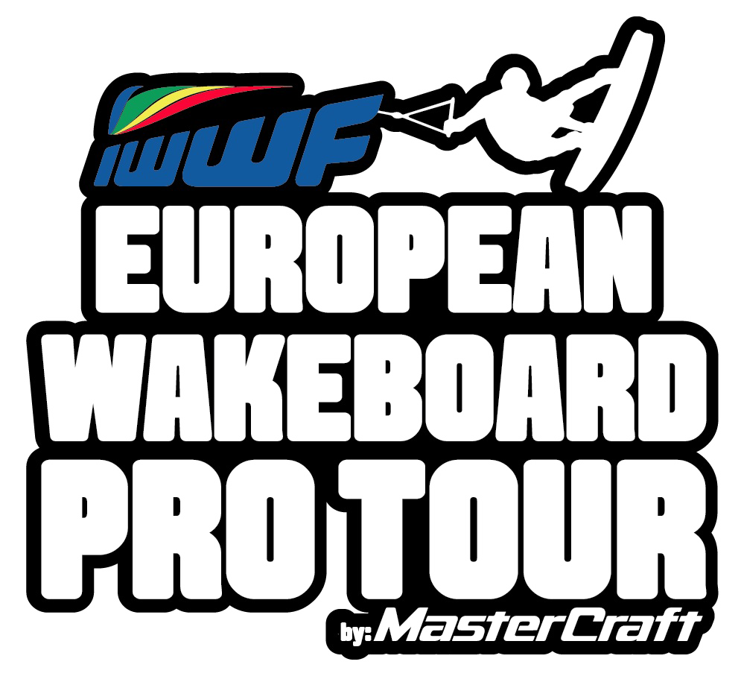

INFORMATION BULLETIN

THE PRO TOUR FORMAT

During 2018 the European Pro Tour will consist of 3 Qualifier Stops
Cash Prize Fund - $10,000 each stop

3 Qualifer Stops - Cash Prize Fund of $10,000 at each Stop

Stop 1 : 7th July – Montargil, Portugal
Stop 2 : 14th July – Toutainville, France
Stop 3 : 21st July – Birmingham, UK

The SuperFinal - Cash Prize Fund - $15,000

3rd August – Rieti, Italy - Cash Prize Fund of $15,000

The Superfinal will take place at the E&A Championships in Rieti, Italy

ELIGIBILITY

- Pro Men and Pro Ladies Divisions only - 20 Men / 10 Ladies
- 30 Riders – on a first come – first served basis
- Riders from E&A only
- In order to compete in the Superfinal, Riders must compete in the IWWF - E&A Wakeboard Boat Championships in the current year
- Entries from the following age divisions: -
Master Men
Open Men and Open Ladies
Junior Men and Junior Ladies

REGISTRATION

Registration for Stop 1 will open on Friday 1st June at 09:00 AM GMT
by email to the following address:
Linda.johnston@wakeboardcouncil.com

Registration emails received before the official time will not be considered.
A confirmation email will be sent within 24 hours to confirm to riders that they have been registered for the competition.

Entries will only be accepted by email, as detailed above, on the official entry form (attached)

The Entry fee is €50 per Qualifier Stop

Register early as this is an opportunity to claim your place at the
IWWF - E&A SuperFinal, to be held at the IWWF - E&A Wakeboard Boat Championships 2018, with a $15,000 Cash Prize fund.

OFFICIAL TOWBOAT

MasterCraft is our partner and Official Sponsor.
MasterCraft will be the official towboat for both the Pro Tour and the IWWF - E&A Wakeboard Boat Championships 2018

UNOFFICIAL PRACTICE

The practice sessions will not be official.
Practice will be available on the Friday afternoon, the day before the event

THE SUPERFINAL - 3rd August, Rieti, Italy

- Pro Men and Pro Ladies Divisions only
- 30 Riders – 10 Ladies and 20 Men
- All Riders who compete in the Qualifier Stops will be ranked
- To particpate in the SuperFinal - Riders must participate in the
IWWF - E&A Wakeboard Boat Championships in the current year

Pro Men Division

Top 10 Men from the Qualifier ranking
Top 3 Semis Group 1 Open Men – E&A
Top 3 Semis Group 2 Open Men – E&A
Top 2 Semis Group 1 Junior Men – E&A
Top 2 Semis Group 2 Junior Men – E&A

Pro Ladies Division

Top 4 Pro Ladies from the Qualifer ranking
Top 2 Qualification Group 1 Open Ladies – E&A
Top 2 Qualification Group 2 Open Ladies – E&A
Top 1 Qualification Group 1 Junior Ladies – E&A
Top 1 Qualification Group 2 Junior Ladies –E&A

Where the top riders in the semi finals of the E&A Championships have already pre-qualified then the place will be given to the next rider who has not pre-qualified.

QUALIFIER STOP 1 : Montargil, Portugal – 7th July 2018

THE VENUE : Hotel NAU Lago Montargil. Attached you can see some information about the hotel.

Room rates : Single – 95 € per room per night
Double – 110 € per room per night

Please send an email to nuno.eca@wakeboardcouncil.com in order to book your room no later than the 13th of June. The hotel may not have availability from that date on, so it is very important you book your room as soon as possible.

https://www.lagodemontargilhotel.com/en/

THE WEATHER : Weather in July is quite warm. Average air temperature of 24º and water temperature of 22º C

LOCAL CURRENCY : The currency in Portugal is Euro - €. Be aware, there is no cash machine (ATM’s) at the Resort. The nearest machine is located at 2km away. The following Credit Cards are accepted in most stores and hotels: Visa, MasterCard, American Express

TRANSPORT : The best way to get to the hotel is by renting a car. The hotel is situated around 110 km from Lisbon Airport.
Please check https://www.lagodemontargilhotel.com/en/location-and-contacts.html to see how to get to the hotel.

PROVISIONAL SCHEDULE – Qualifier Stops

Friday p.m 14.00 - 20.00 Unofficial practice
Friday p.m 20.00 - end of Registration
Saturday 08.30 – Rider Briefing
Saturday a.m. Qualifying Rounds
Saturday a.m LCQ Rounds
Saturday p.m Semi-Finals
Saturday p.m Finals

Prize Ceremony
Dinner

CONTACTS

Linda.Johnston@wakeboardcouncil.com
Maria.bulgakova@wakeboardcouncil.com

THE IWWF – EUROPEAN WAKEBOARD BOAT PRO TOUR QUALIFIER STOP 1
Montargil - Portugal

REGiSTRATION FORM

First Name :

Surname :

Date of Birth :

Country

Home Address

Email Address

Mobile Phone

Bank Details
Name and Address of Bank
IBAN
BIC

Send this entry form to linda.johnston@wakeboardcouncil.com

Entries Open 1st June 2018 at 09.00am GMT
Entries for Stop 1 will close on 17th June 2018

NB: Entries by email only.

